IMPORTANT: Some features used in our PDF documents may not work when using certain in-browser viewers, such as Microsoft Edge and Google Chrome. If you encounter issues, please open the document using your browser then download/save it to your computer as a PDF document. Open the saved PDF with Adobe Acrobat and all features should now work. However, we do not recommend saving these documents for future use. Always return here to be sure you are viewing the most up-to-date and accurate documents.

In order to access and complete form CS-118, please click this link http://www.dot.state.pa.us/public/PubsForms/Forms/CS-118.zip, do not click “download file” at the top of your screen.

A Window will appear in the upper Right corner of the screen that looks like this.
Click on the 3 dots here next to where the file is listed.

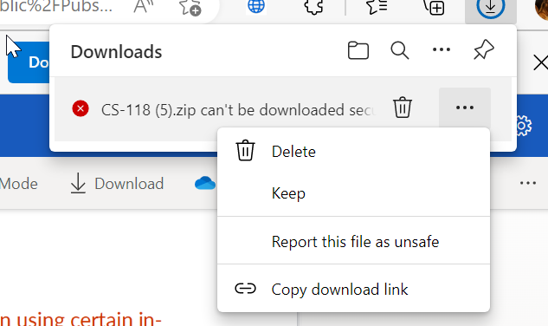

Click “keep”
Then click “keep anyway”

